**PRACTICAL 1**

**Name:** Smit M Khobragade

**Sec:** A

**Roll no.:** 64

**AIM:** Study of Windows Programming.

**Code & Output:**

1. Write a program that prints the value of hInstance in a message box.

#include <stdio.h>

#include <stdlib.h>

#include <windows.h>

int _stdcall WinMain(HINSTANCE *hinstance*, HINSTANCE *hprevinstance*, LPSTR *ipsz*, int *cmdshow*)

{

  char str[10];

  sprintf(str, "HINSTANCE value: %d", hinstance);

  MessageBox(0, str, "Smit Khobragade", MB_ABORTRETRYIGNORE);

  return 0;

}

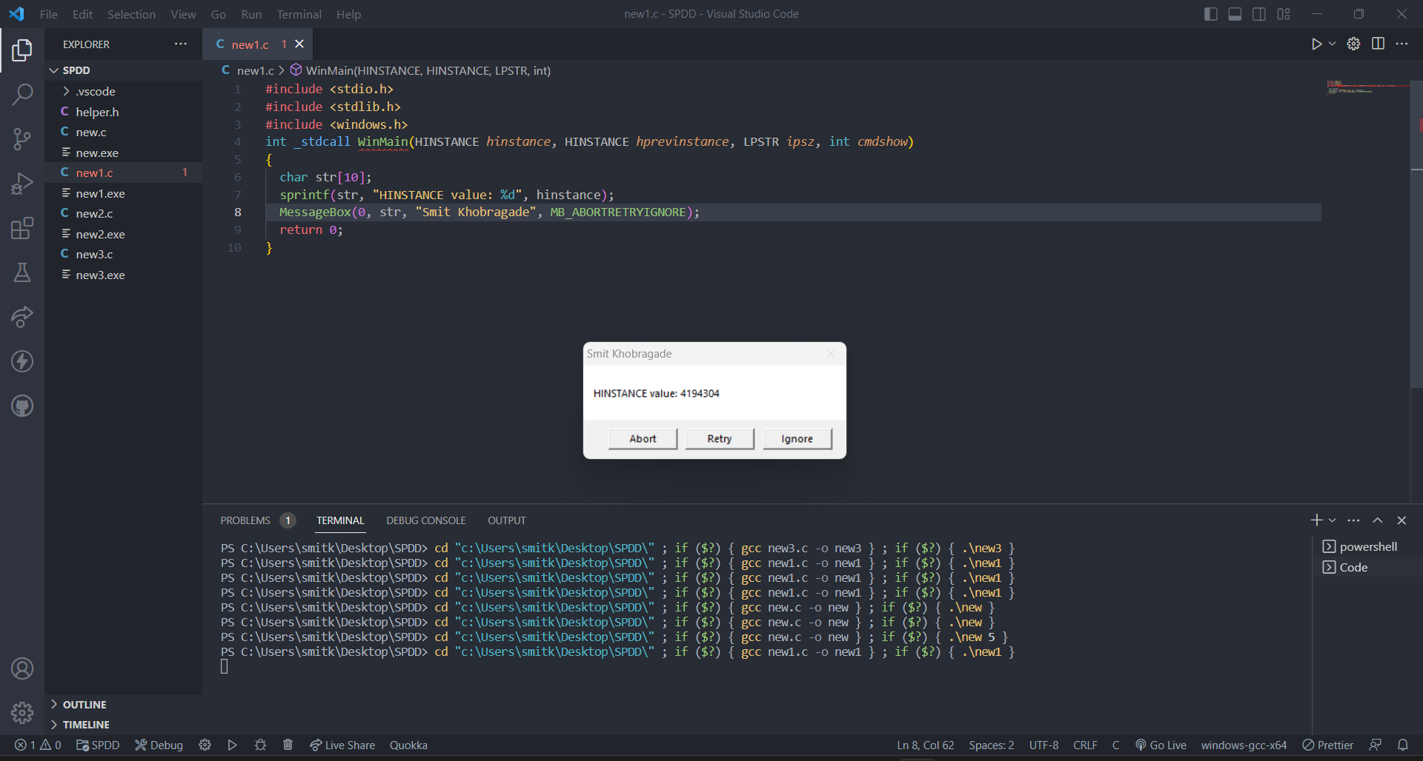

1. Write a program that receives a number as a command line argument and prints its factorial value in a message box.

#include <stdio.h>

#include <stdlib.h>

#include <windows.h>

int _stdcall WinMain(HINSTANCE *hinstance*, HINSTANCE *hprevinstance*, LPSTR *ipsz*, int *cmdshow*)

{

  char str[50];

  int num, i, f = 1;

  sprintf(str, "Factorial of %d : %d", num, f);

  num = atoi(ipsz);

  for (i = 1; i <= num; i++)

  {

    f = f * i;

  }

  sprintf(str, "Factorial of %d : %d", num, f);

  MessageBox(0, str, "Smit Khobragade", MB_OK);

  return 0;

}

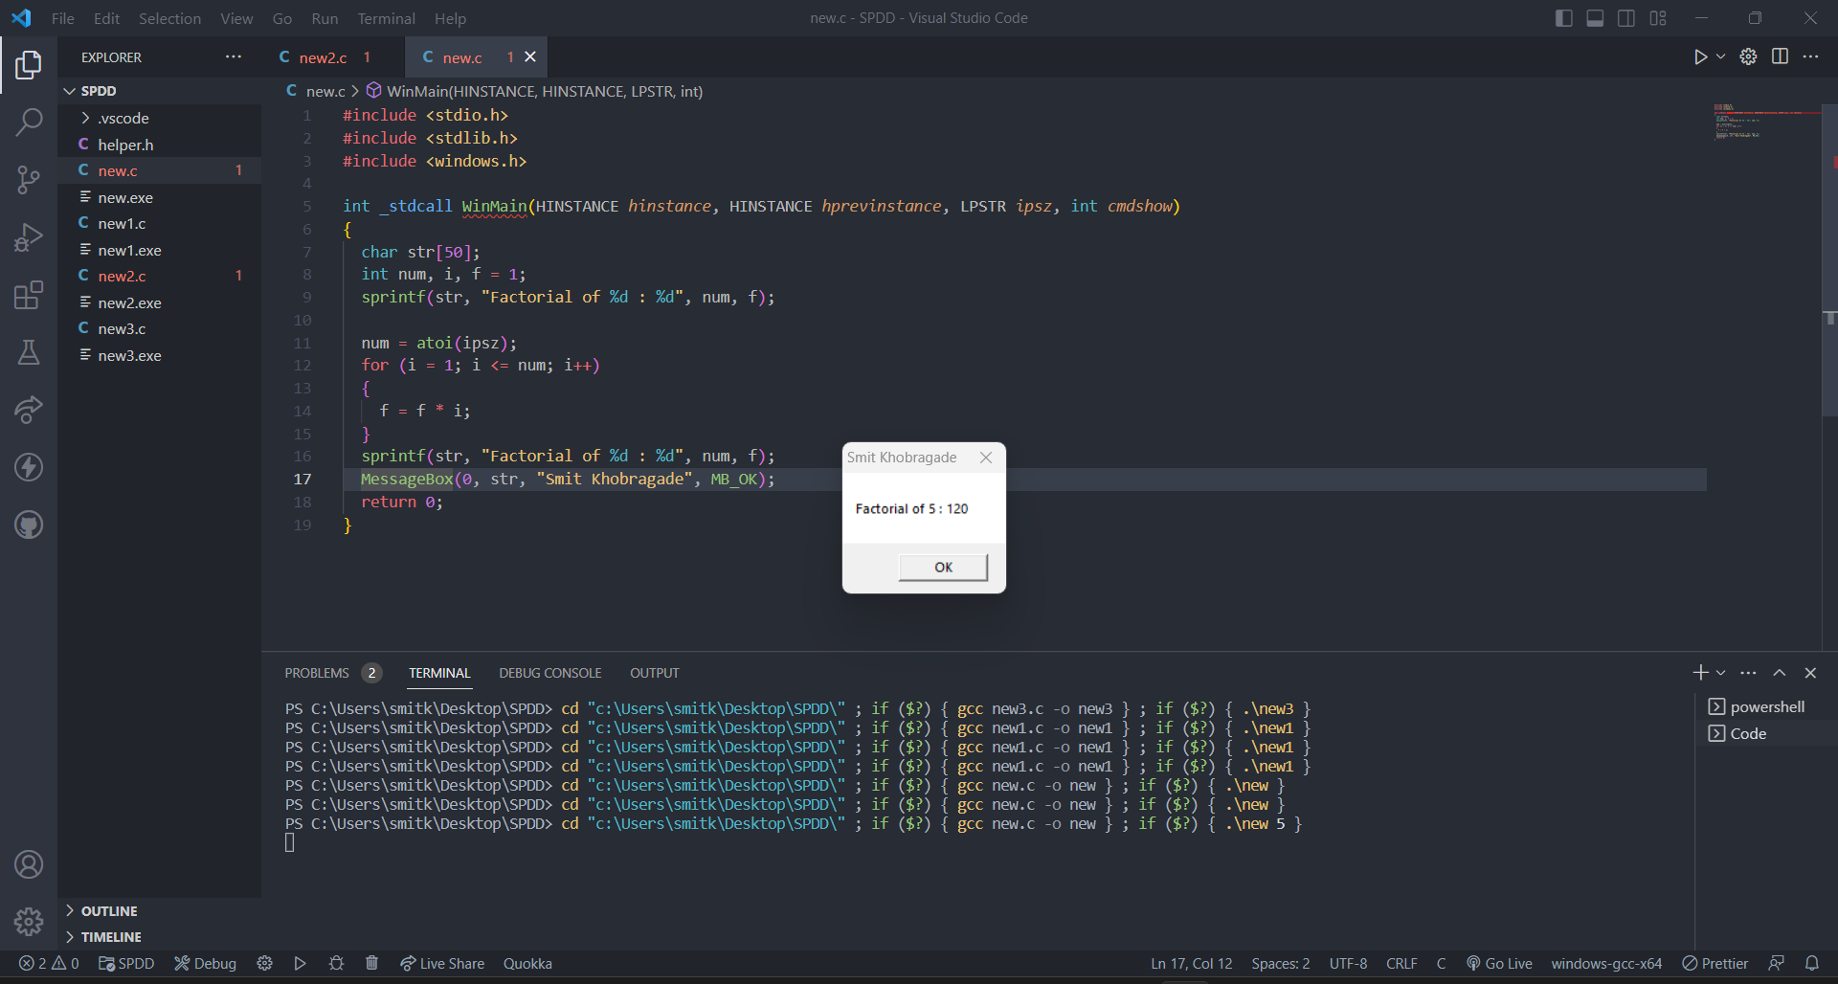

1. Write a program that receives a string of words as a command line argument and print the count of no. of words

#include <stdio.h>

#include <stdlib.h>

#include <windows.h>

int _stdcall WinMain(HINSTANCE *hinstance*, HINSTANCE *hprevinstance*, LPSTR *ipsz*, int *cmdshow*)

{

  char str[50];

  sprintf(str, "%s", ipsz);

  int count = 0, i = 0;

  while (str[i] != '\0')

  {

    if (str[i] == ' ')

    {

      count++;

    }

    i++;

  }

  sprintf(str, "%d", count + 1);

  MessageBox(0, str, "Number of words (Smit Khobragade)", MB_OK);

  return 0;

}

